Problem Statement

• Create a freestyle project with the name QA_UNIT_TEST in Jenkins that is driven from job DEVELOPER_CODE_REVIEW and performs unit testing Take a screenshot of the console output showing a successful build of unit testing

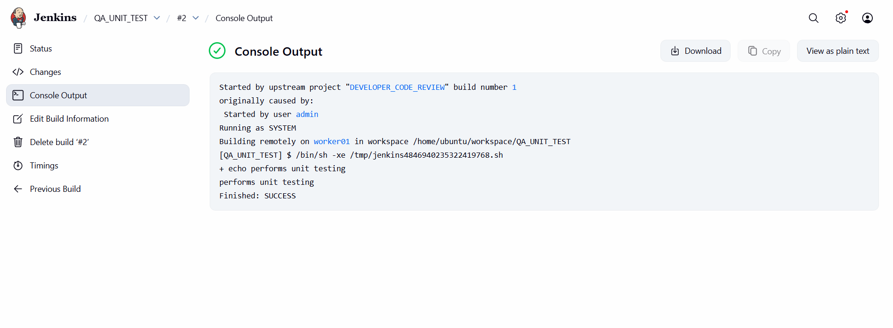

• Create a freestyle project with the name QA_METRICS _CHECK in Jenkins to check the test cases. Make sure the Cobertura plugin is installed in Jenkins Take a screenshot of the metrics from the dashboard of the project. 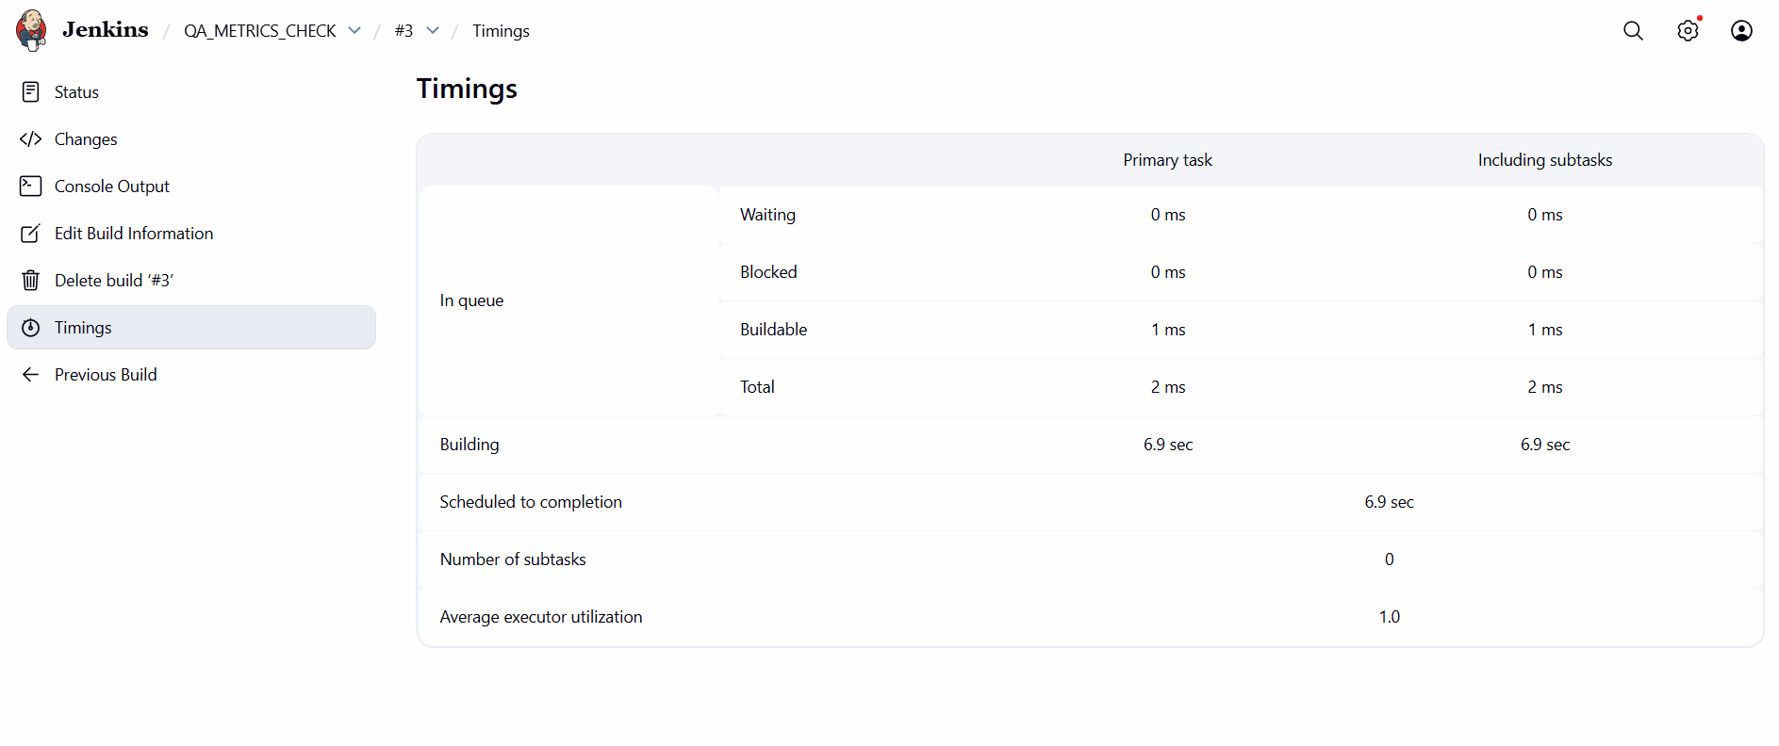

• Create a freestyle project with the name QA_PACKAGE in Jenkins to create an executable jar/war file. Take a screenshot of the target folder created in the workspace. 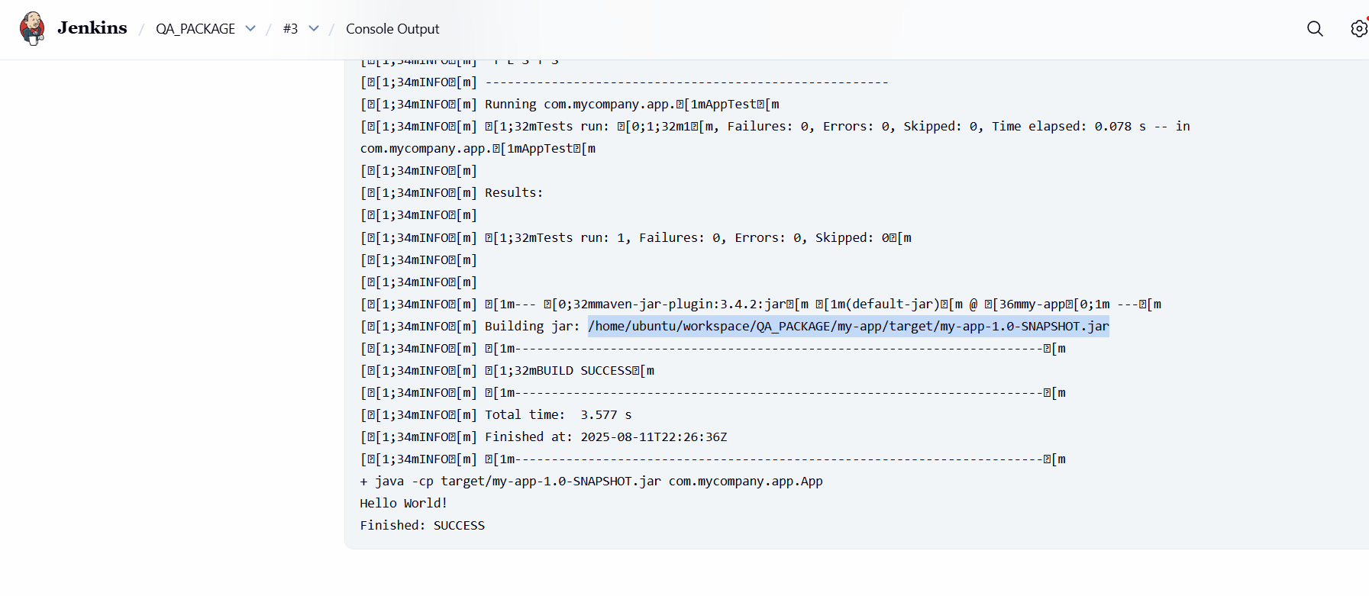

• Create a pipeline named SAMPLE_COMPILE_VIEW with Build Pipeline View option, select DEVELOPER_COMPILE project under layout section, and run the pipeline to check the console output Take a screenshot of the pipeline dashboard showing the status of the projects

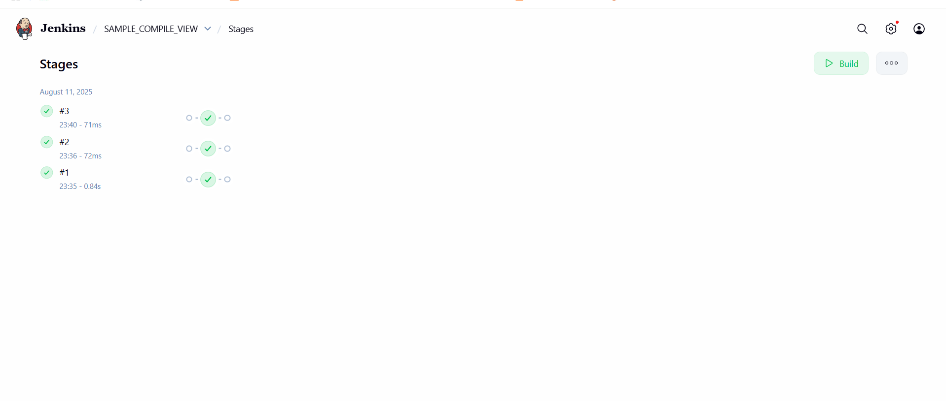

• The pipelines can also be extended to running web tests and load tests. Explain how you would do the same using Jenkins?

**We will take help from Developer in preparing use case and test cases. With help of developers, we will create web and load test using Jenkins.**